This is a simple expert system for diagnosing some lung diseases with info from https://www.lung.org/lung-health-and-diseases/lung-disease-lookup/

Test cases for my code and how to use it, you must use SWI-Prolog and then fallow these steps

1. consult the file(ai_hw08.pl) in SWI-Prolog once that is done
2. Use the command *(start).* To begin the program
3. Answer the questions with an *n.* or *y.* IMPORTENT: **Use a “.” after every one of your inputs else you will stall.**

The code uses the questions to guess what lung disease the patient probably has by asking the user questions on the symptoms. It then goes down the list of all possible lung diseases to see what is the most likely to be the lung disease that the patient has.

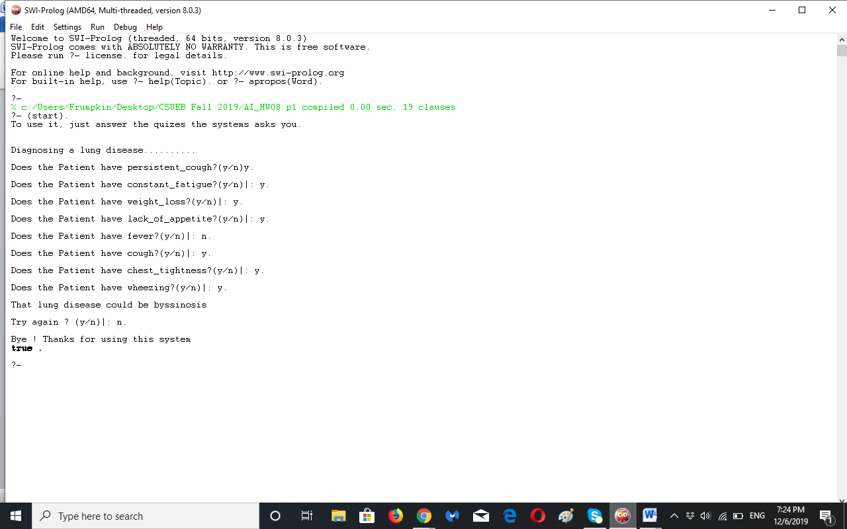

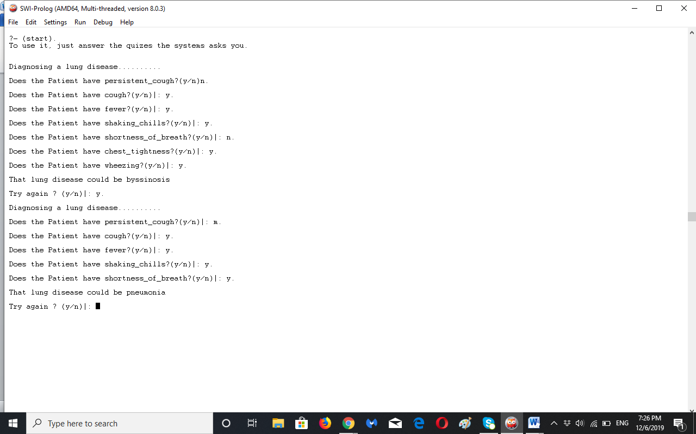

Here are the rules and facts:

Facts for the disease

disease(Patient,tuberculosis):-

symptom(Patient, persistent_cough),

symptom(Patient, constant_fatigue),

symptom(Patient, weight_loss),

symptom(Patient, lack_of_appetite),

symptom(Patient, fever),

symptom(Patient, coughing_blood),

symptom(Patient, night_sweats).

disease(Patient,pneumonia):-

symptom(Patient, cough),

symptom(Patient, fever),

symptom(Patient, shaking_chills),

symptom(Patient, shortness_of_breath).

disease(Patient,byssinosis):-

symptom(Patient, chest_tightness),

symptom(Patient, cough),

symptom(Patient, wheezing).

disease(Patient,pertusis):-

symptom(Patient, runny_nose),

symptom(Patient, mild_fever).

disease(Patient,pneumoconiosis):-

symptom(Patient,chronic_cough),

symptom(Patient,shortness_of_breath).

disease(Patient,sarcoidosis):-

symptom(Patient, dry_cough),

symptom(Patient, shortness_of_breath),

symptom(Patient, mild_chest_pain),

symptom(Patient, scaly_rash),

symptom(Patient, fever),

symptom(Patient, red_bumps_on_legs),

symptom(Patient, sore_eyes),

symptom(Patient, swollen_ankles).

disease(Patient,asbestosis):-

symptom(Patient, chest_tightness),

symptom(Patient, shortness_of_breath),

symptom(Patient, chest_pain),

symptom(Patient, lack_of_appetite).

disease(Patient,asthma):-

symptom(Patient, wheezing),

symptom(Patient, cough),

symptom(Patient, chest_tightness),

symptom(Patient, shortness_of_breath).

disease(Patient,bronchiolitis):-

symptom(Patient, wheezing),

symptom(Patient, fever),

symptom(Patient, blue_skin),

symptom(Patient, rapid_breath).

disease(Patient,influenza):-

symptom(Patient, headache),

symptom(Patient, fever),

symptom(Patient, shaking_chills),

symptom(Patient, nasal_congestion),

symptom(Patient, runny_nose),

symptom(Patient, sore_throat).

disease(Patient,lung_cancer):-

symptom(Patient, cough),

symptom(Patient, fever),

symptom(Patient, hoarseness),

symptom(Patient, chest_pain),

symptom(Patient, wheezing),

symptom(Patient, weight_loss),

symptom(Patient, lack_of_appetite),

symptom(Patient, coughing_blood),

symptom(Patient, headache),

symptom(Patient, shortness_of_breath).

rules

symptom(_P, Val):-ask('Does the Patient have',Val).

ask(Obj, Val):-known(Obj, Val, true),!.

ask(Obj, Val):-known(Obj, Val, false),!, fail.

ask(Obj, Val):-nl,write(Obj),write(' '),

write( Val) , write('?(y/n)'), read(Ans), !,

((Ans=y, assert(known(Obj, Val, true)));(assert(known(Obj, Val, false)),fail)).

diagnose:-nl,write('Diagnosing a lung disease..........'),nl,disease(symptom,Disease) ,!,nl,

write('That lung disease could be '), write(Disease).

diagnose:- nl, write('Sorry,we may not be able to diagnose the desease!!').

start:-notice,repeat, abolish(known/3),dynamic(known/3), retractall(known/3), diagnose,nl,nl, write('Try again ? (y/n)'),read(Resp),\+ Resp=y,

nl,write('Bye ! Thanks for using this system'),abolish(known,3) .